|  |  |  |  |  |  |  |  |  |  |  |  |  |
| --- | --- | --- | --- | --- | --- | --- | --- | --- | --- | --- | --- | --- |
| |  |  | | --- | --- | | Butter | Onion | | Garlic | Flour | | Chicken Stock | Salt | | Pepper | Paprika | | Broccoli | Carrot | | Half & Half | Cheddar Cheese |  Ingredients Without Measurements |

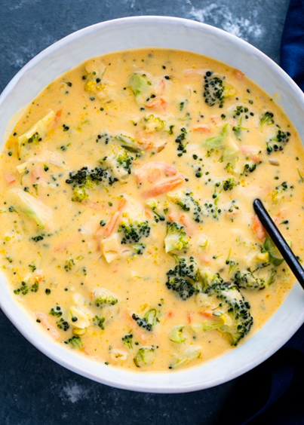Broccoli Cheddar Soup

|  |
| --- |
| Ingredients With Measurements  * 4 tablespoon butter * ½ medium onion chopped * 2-3 cloves garlic minced * 4 tablespoon AP flour * 2 cups low sodium chicken or vegetable stock * 1 teaspoon kosher salt * ½ teaspoon black pepper * ¼ teaspoon [paprika](http://amzn.to/2tSOu1J) or ground nutmeg, optional * 3 cups broccoli florets or 1 large head, cut into small pieces * 1 large carrot grated, julienned or finely chopped * 2 cups half & half or milk or light or heavy cream * 8 oz block grated cheddar cheese or 2 cups |

|  |
| --- |
| Recipe Melt butter in a large Dutch oven or pot over medium-high heat. Add the onion and cook 3-4 minutes or until softened and light gold. Add the garlic and sauté for another minute.  Add flour and whisk for 1-2 minutes or until the flour begins to turn golden in color. Pour in the chicken stock, broccoli florets, carrots, and seasoning. Bring to a boil then reduce heat to medium-low and simmer for 15 minutes or until the broccoli and carrots are cooked through.  Stir in half & half and cheddar cheese and simmer for another minute. Taste and adjust seasoning if needed. |